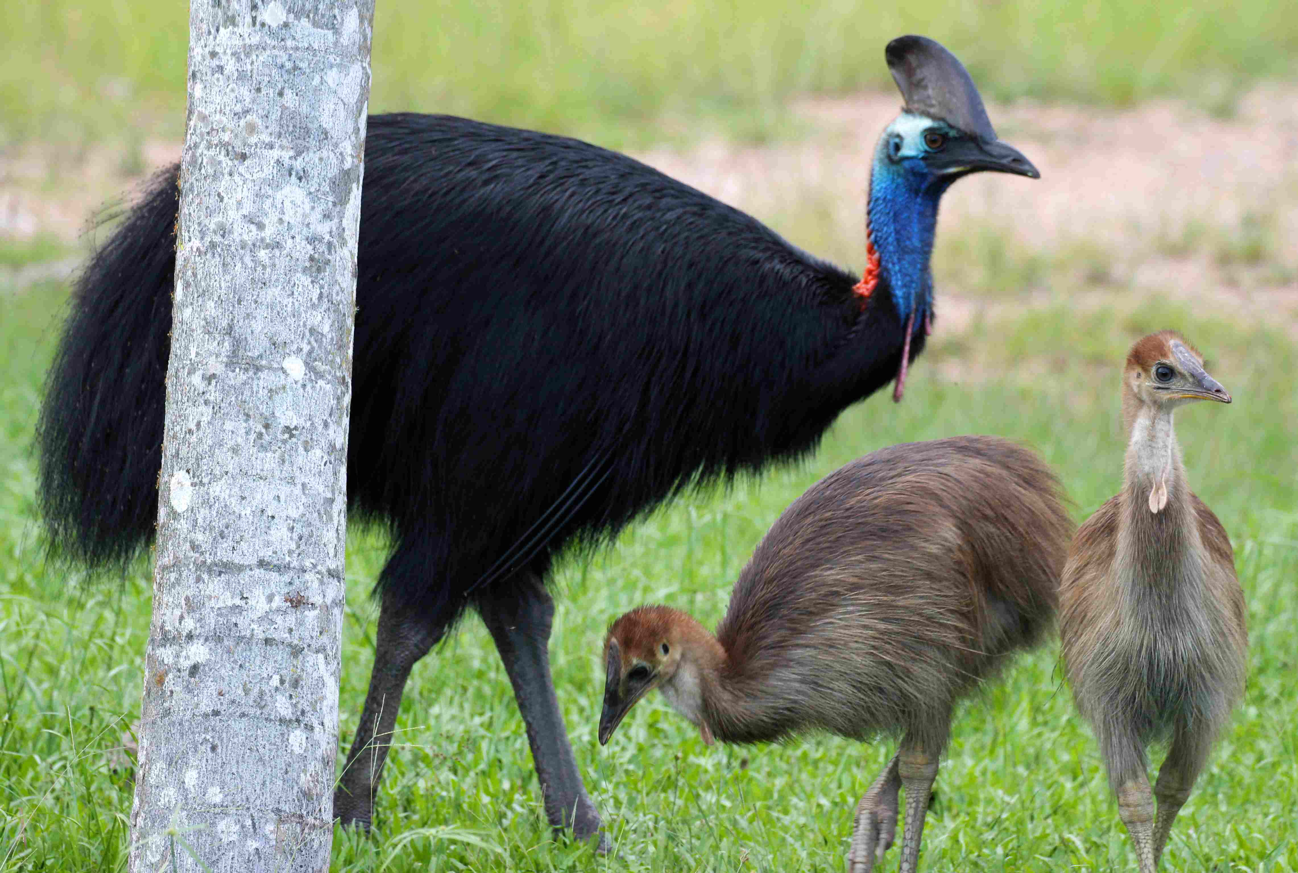

Household scraps should be composted or disposed of where they will not attract cassowaries.

Confine all dogs within fences. Dogs are a serious threat to cassowaries and other wildlife and cassowaries have been known to injure dogs.

Keep your distance. If you are lucky enough to see a cassowary in the wild appreciated it from a distance. Be aware that this endangered species is also an unpredictable and potentially dangerous animal. When threatened they can use their clawed toes as weapons, jumping and kicking forward with both feet at once. Do not approach or try to pick up chicks.

When driving in cassowary habitat slow down and watch out for cassowaries and chicks on the road or road edges. Colliding with a cassowary may result in injury or death of the bird and cause considerable damage to your vehicle.

Don’t stop your car to look at birds on the road – this is dangerous for you, other drivers and cassowaries. Warn other drivers of birds near or on the road by flashing your headlights at oncoming traffic.

**FOR MORE INFORMATION**

Qld. Parks & Wildlife

Ph: 07-4046-6600

Leave gully heads vegetated. Cassowaries benefit from the extra feeding grounds and erosion is reduced.

Contact local Queensland Parks and Wildlife Service extension officers, local Landcare groups, cassowary conservation groups or shire council nurseries if you wish to become involved in tree planting and the habitat restoration projects.

**LIVING WITH CASSOWARIES**

Where they still occur cassowaries occasionally come into contact with people either along roads and walking tracks or on the fringes of urban areas. If future generations are to experience this amazing bird we have a responsibility to ensure that cassowaries continue to live undisturbed throughout their current range. Removing cassowaries from conflict situations is not the answer. We must modify our behavior to avoid conflict. By following these basic steps we can do our bit for cassowary conservation:

**Do Not FeedThe Cassowary**

If fed from cars cassowaries learn to associate cars with food. As a result they frequent roads, often with fatal results. Cassowaries which are used to being fed can become demanding, aggressive and dangerous.

**THE CASSOWARY & COMMUNITY NATURE CONSERVATION**

Before white settlement and the subsequent clearing of forest areas in the far north, the cassowar4y was much more common and widespread. Settlement led to the removal of extensive areas of forest to open the way for agriculture.

As the rainforest and associated habitat disappeared so too did the cassowary. Today much of the former range of the wet tropics cassowary population has been converted to farmland, with the remaining habitat widely fragmented. In such areas as the Atherton Tablelands the cassowary is a rare sight.

Although habitat loss is the most serious threat to the cassowary vehicles, attacks by dogs, shooting, disease and accidental capture in feral pig traps all contribute to the decline of this endangered species.

Private landowners, conservation groups and individuals can assist the Queensland Parks and Wildlife Service to conserve our remaining cassowary population by adopting these measures:

Retain remnant habitat including vegetation along creek banks and retain or re-establish corridors linking remnant habitat patches. These corridors assist movement of fauna from one patch of forest to the next while preserving the scenic quality of the landscape.

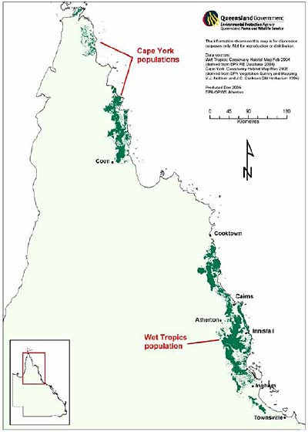

**RESEARCH INTO CASSOWARIES**

Cassowary populations have suffered from the large scale clearing and degradation of wet tropical forest habitats. Because of this, natural events such as cyclones causing short term food shortages can lead to a serious decline in cassowary populations especially in disturbed habitat.

To understand more about the cassowary and to ensure its continued survival, the Queensland Parks and Wildlife Service, in co-operation with Environment Australia, Commonwealth Scientific Industrial Research Organisation, James Cook University and independent researchers are conducting research programs on cassowary distribution and biology.

The aims of the research are:

To develop reliable techniques for monitoring the distribution and health of cassowary populations.

To accurately assess and monitor the distribution and numbers of cassowaries throughout their range.

To obtain data on mortality of immature cassowaries and factors affecting recruitment to the adult populations.

To determine appropriate management practices for the maintenance and protection of cassowary habitat.

These data should enable the development of sound management strategies aimed at long term conservation of wild populations of cassowaries.

Quite often the only visible signs you might find to indicate that a cassowary has been visiting the area is a pile of dung or perhaps a footprint. The sheer sized of the three-toed footprint (up to 180mm long) makes cassowary tracks easy to recognize. The dung piles are also very distinctive – generally about 150-200mm across filled with seeds of forest fruits and coloured by the fruit skins, often a purplish brown.

**CASSOWARY SIGNS**

Those people fortunate enough to see a cassowary in the wild will notice how well it blends with its surroundings. Even the colourful wattles help to break up the bird’s outline. These features and the bird’s slow confident movements help the cassowary to become almost invisible in the shadows of the forest.

Females are usually larger than males. The tail feathers on mature males appear longer than on females.

Newly hatched chicks are striped dark brown and creamy white. Between 3 and 8 months the stripes fade and the plumage changes to brown. As the young mature the plumage darkens, the wattles and casque develop and the skin colour on the neck and wattles brightens. The cassowary is mature at about 3 years of age. There are reports of cassowaries living 30-40 years in the wild and up to 60 in captivity.

**TERRITORY & BEHAVIOUR**

The cassowary is territorial and solitary, with contact between mature individuals generally only tolerated during mating. Cassowaries use vocalization to announce their presence to each other and thereby minimize contact.

One study indicated an average home range of 75 hectares although size varies with habitat and food availability. Home ranges of individual cassowaries overlap to a limited degree. From month to month there is considerable variation in the amount of the home range used depending upon the availability of fruit.

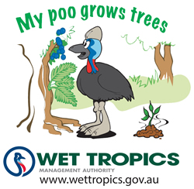

They are one of the only native animals that are capable of dispersing the seeds of trees with large fruits.

Because of their importance for plant dispersal, cassowaries are considered ‘keystone’ species. This means that the loss of cassowaries could lead to long term changes to plant communities and subsequent loss of individual plant species.

**REPRODUCTION**

Breeding usually occurs from June to October, although chicks have been reported from May to January. Both males and females will initiate courtship and generally mate over several weeks until all the eggs are laid. They can mate with more than one partner during a season with several females sometimes laying in the same nest.

An average of four lustrous olive green eggs are laid directly on the forest floor in an enclosed sheltered environment. Over time the egg tending activities of the male results in a nest-like accumulation of leaves and sticks. The male incubates the eggs alone for about 50 days often going long periods without food and water.

The male takes sole responsibility for rearing the chicks which takes about 12 months. After this the young ones must seek out their own territory. The sub-adult mortality rate is high as opportunities to establish new home ranges are limited particularly in areas where significant loss and fragmentation of habitat has occurred.

Cassowaries will aggressively defend their territory if necessary. Dominance is usually decided by what is called a stretchy display. This involves stretching the neck, raising the feathers and issuing a rumbling call. If this progresses into actual conflict then the two birds will crash together while leaping into the air and kicking with the dagger-like inner claw. In some individuals this claw may be up to120mm long.

**DIET**

While rainforest fruits that fall to the ground from the canopy are the primary food source, cassowaries will eat almost any edible object. This includes flowers, fungi, snails, earthworms, insects, spiders, small dead animals and even live mammals such as rats and mice. The cassowary is diurnal (active during the day) and forages from sunrise to sunset, with peak feeding periods during the early morning and late afternoon. Cassowaries eat the fruits from over 150 rainforest trees, palms, cycads, shrubs, herbs, vines and epiphytes. Some of the dominant food trees include quondongs, satinash, onionwood, white accia, walnuts, laurels and palms.

Cassowaries have primitive and relatively inefficient digestive systems which digest only the soft outer flesh of fruits and excrete the seeds whole. Cassowaries travel large distances dropping the seeds of a wide range of fruiting plants as they go.

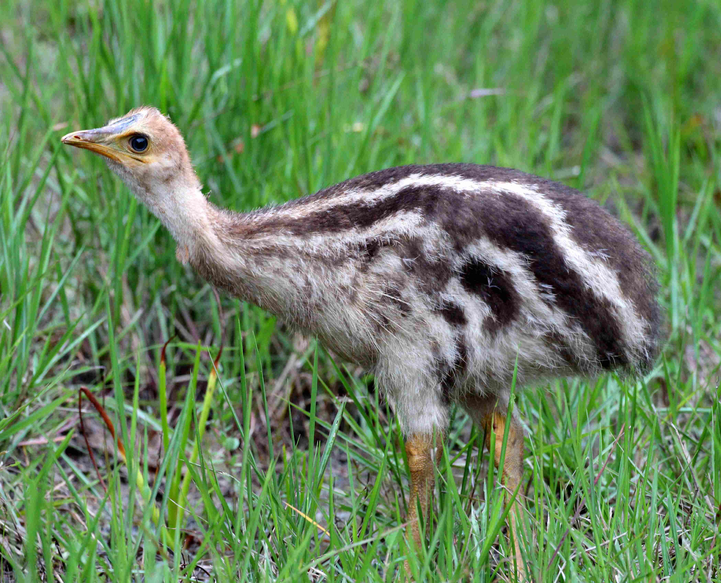

The Cassowary in Queensland

**Appearance**

It is hard to mistake the cassowary for any other Australian rainforest bird. Its impressive size, coarse glossy black plumage, tall helmet and brilliant red and blue neck and wattles are easily identifiable features. Adults can stand up to two metres tall and weigh up to 85 kilograms, although the average is about 38 kilograms for males and about 47 for females.

Like the other races the cassowary has some unusual features. One of these is the extraordinary feathers which have two shafts giving the feather a hair-like appearance. The reason for the evolution of feathers of this type is unknown, though they may be more effective for insulation and for shedding rain than feathers which are adapted for flight.

The tall helmet or ‘casque’ that forms on maturing birds and continues to grow with age consists of light, cellular, foam-like material covered by a delicate (keratinous) skin. Despite it horny appearance, the casque is very delicate and easily damaged. The casque may serve as an indicator of age and dominance amongst cassowaries.

Male and female cassowaries are similar in appearance with no obvious colour variation.

**A Special queenslander**

The southern cassowary (Casuarius casuarius) is one of the most striking and certainly by far the largest bird to be found in Australian rainforests. It is a member of the ratite group of birds comprising the large flightless land birds with a keel-less breastbone, hairlike feathers and three forward pointing toes. The group has relatives throughout the southern hemisphere and includes such birds as the rhea of South America, the ostrich of Africa, New Zealand’s kiwis and the Australian emu.

There are three species of cassowary. Only one of these is found in Australia while the others are indigenous to New Guinea and some of the adjacent islands. In Australia the birds are restricted to north Queensland’s wet tropical forests and some small isolated areas of north-eastern Cape York Peninsula.

The cassowary is listed as an endangered species under Queensland and Commonwealth legislation. It is estimated that as few as 4000 cassowaries remain in the wild. The continuing loss of cassowary habitat gives cause for concern about the long term survival of this magnificent bird.

