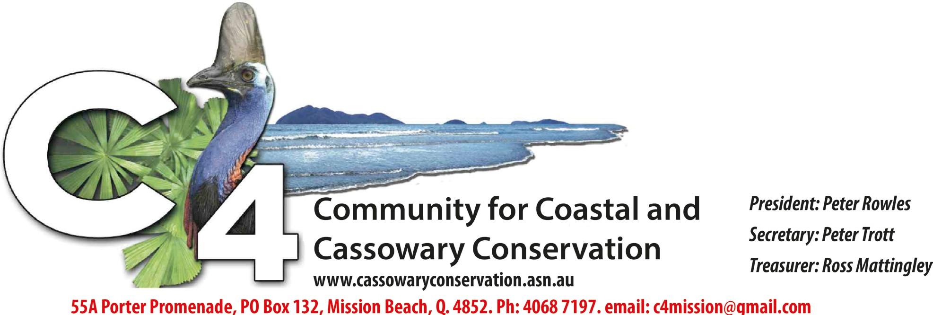
Be Aware for Cassowaries
May 2022

Picnic meeting this Saturday

Members and friends and anyone else interested are invited to a picnic meeting at the Gurrbum Nature Refuge revegetation site on Old Tully Road, Smiths Gap, at 2pm on Saturday, May 7.
We will car pool at Gurrbum (17.8496S, 145.98082E, near the cane railway crossing), travel to view C4’s new land purchase on Bruce
Highway near the road works depot and then our cassowary underpass project at Big Maria Creek before returning to Gurrbum for the picnic meeting. Please bring your own eats, drinks, chairs and ideas.
Further information from Peter Rowles 0429179152 or Peter Trott 0407966965.

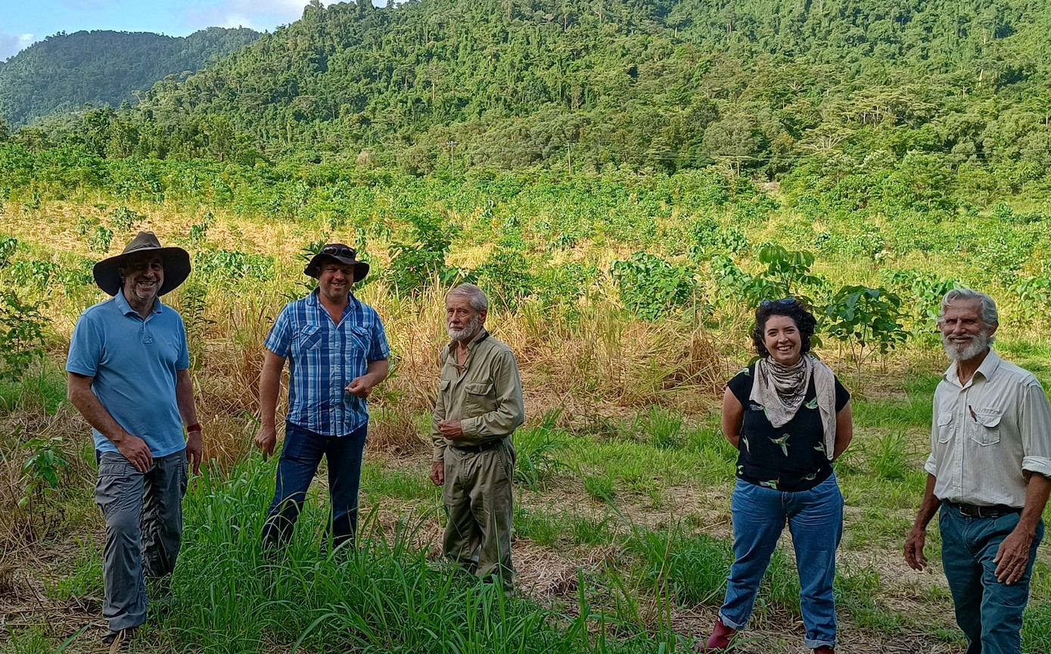Greenfleet reviews corridor progress
Three senior members of Greenfleet, a charity which is funding part of our revegeta- tion effort at Gurrbum Nature Refuge and cassowary corri- dor, visited the site last week with C4 committee members to review the achievements there since the former banana farm was acquired in partner- ship with Queensland Trust for Nature three years ago.
Greenfleet’s general manag- ers of partnerships, Michael
Coleman, marketing and

engagement, Annabel O’Neill, and revegetation, Alex Pad-
Greenfleet’s Alex Paddock, Michael Coleman and Annabel O’Neill at Gurrbum with C4 secretary Peter Trott (centre) and president Peter Rowles (right).

dock, trekked around the whole site inspecting the different stages of growth and discussing the revegetation methods used.
It was agreeed that the techniques used in all reveg- etation projects in the Wet Tropics should be brought together through a research study to inform future pro- jects and thereby achieve
maximum “bang for buck”.
Greenfleet is a not-for-profit organisation and Australia’s first carbon offset provid- er, committed to protecting our climate by restoring our forests. Its objectives are to plant native biodiverse for- ests in Australia and New Zealand to restore critical
ecosystems and capture car- bon emissions on behalf of
its supporters. “Our forests
are legally protected, absorb carbon from the atmosphere, improve soil and water qual- ity, and provide vital habitat for native wildlife,” its website explains. “Our partnerships with local communities and Traditional Owners support broad benefits for the country and communities in which we live and work.”

Garners Cassowary Facility back in action

The contract won by C4 early this year with the Queensland Department of Environment and Science to care for casso- waries at the Garners Beach Cassowary Rehabilitation Facility is fully functional with a team of nine volunteers taking

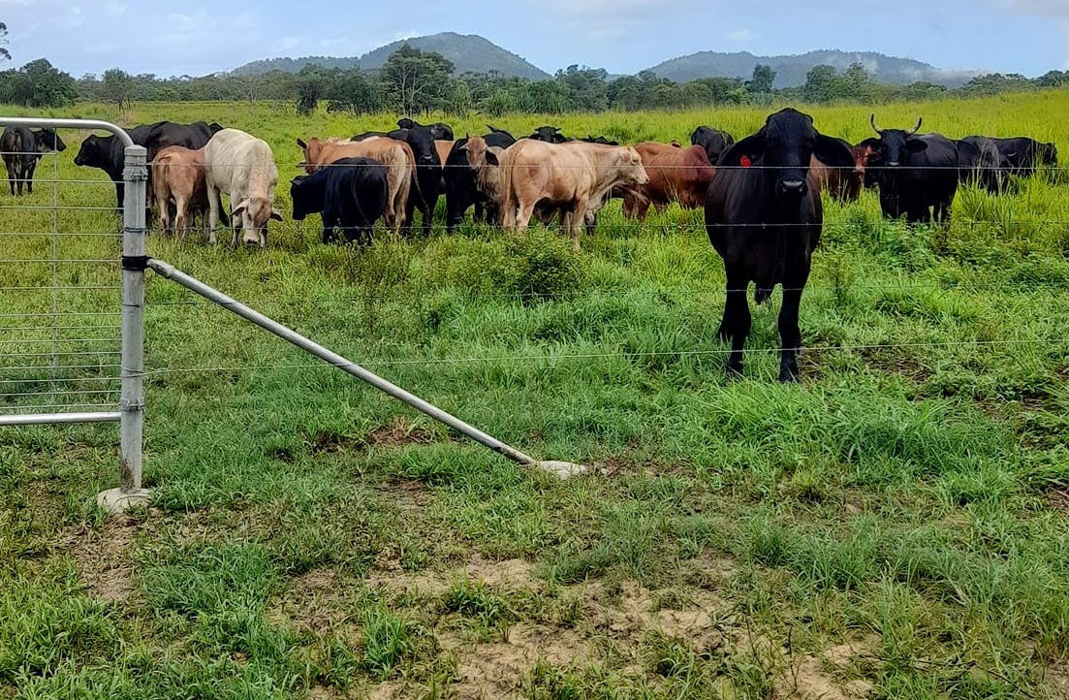
Wired for wildlife
Fencing supplier Whites Wires has invited C4 to take part in a presentation of its Fauna-Friendly fence to potential users follow- ing a successful trial or- ganised by our habitat co- ordinator Ian Shankly on Courtney and Lisa Remil-
turns to prepare food for a six- month-old female (Cassowary 304) which was mauled by a dog at Djiru, near Lacey Creek, treated by Tully Vets and ad- mitted to the facility.
The bird will be returned to the wild when DES wildlife officers
decide it can fend for itself. While at Garners, the bird is fed remotely with no contact with the carers.
This is to minimise bonding with humans and give it the best chance of surviving in the wild.

ton’s Leo Road property between a lane and a graz- ing paddock.
After a couple of months
Cattle in the Leo Road paddock secured by the Fauna-Friendly fence (above) and close-up (below) showing the twisted design of the barbless wire attached to the strainer post.

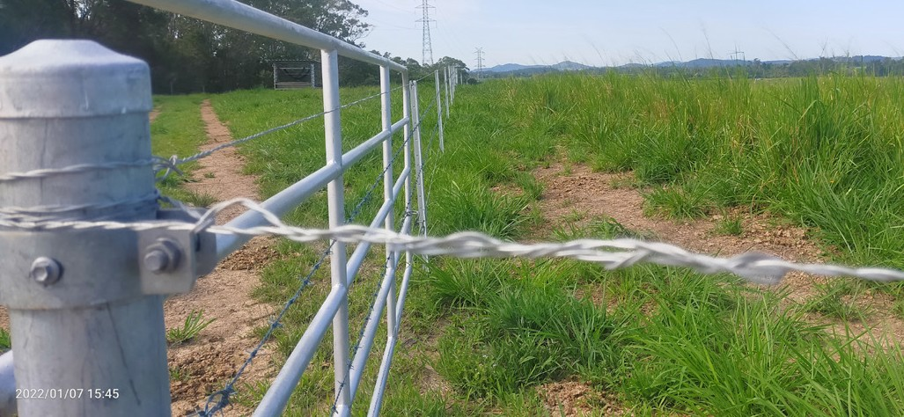
the trial fence, using Whites twisted plain wire design instead of barbed wire for the top and bottom of a four-wire fence, had kept the cattle where they were meant to be and no bats, birds or gliders had been caught.
Over the same period at least two bats died after being caught on the all-barb fence next door.

C4 buys forest block for national park link

A forested 2.2ha block of land between Bruce Highway and the main railway line adjacent
to Walter Hill Environmental Park has been bought by C4 for protection as an addition to the national park.
The block, between Feluga and El Arish, links cassowary and other wildlife habitat with national park and is in line with the corridor being created by Gurrbum Nature Refuge.
The purchase was helped by the fundraising efforts of actors and crew of the Netflix series ‘Irreverent’ while filming at Mission Beach.
Actor Russell Dykstra, an ardent conserva-
tionist and nature lover, encouraged the team to donate to C4’s ‘Give Now’ fundraising platform to buy critical land for cassowary conservation.
The result was a $7600 boost to the fund. Russell and fellow actor and writer Roz Hammond said they had been awed by the region’s natural beauty and touched by the friendliness of the Mission Beach community. C4 president Peter Rowles also thanked local solicitor Jake Robertson for his help with the purchase.

