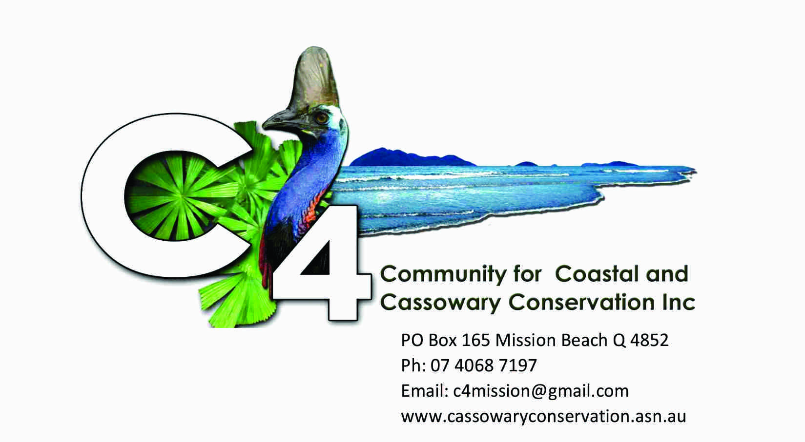

C4 NEWSLETTER/ Notice of meeting November 16, 2015.

NEWS FLASH! IT’S ON SATURDAY DECEMBER 5 AT 5.30PM
The Secret Life of Pigs (in the Rainforest) will be revealed at C4 Christmas Meeting, to be held on Saturday, December 5 at C4, starting at 5.30pm.
Guest speaker is Peter “Piggy” Heise-Pavlov who has spent many years studying feral pigs in the wet tropics environment.
Dr Pavlov is the author of the book: “2000 feral pigs: my part in their downfall”.
So bring your pork chops or a treat to share for supper afterwards.

ALSO, the meeting will be an opportunity to reflect on the state of the beach and foreshore.
A beach walk is planned on the day of the meeting, starting at C4 at 9am and following Ulysses Link to Conch Street, to gain a first-hand assessment of what is going well, what is going wrong and what we can do to increase the first and decrease the latter.
This will be an opportunity to see the site of the proposed extension of the Ulysses Link by building a bridge (The ‘Bridge too far’) across the creek beside C4 then a track through the foreshore vegetation that C4 has been rehabilitating since Cyclone Yasi.

Come along and tell us what you think.
All welcome.
Don’t forget to wear a hat for the walk.

Peter Rowles
President
40687197/0429 179152

